Cognizant Deep Skilling - Week 2 SQL Exercises

Name: Pranjal Yadav

Roll Number: 22052918

# Exercise 1: Ranking and Window Functions

## Table Creation and Sample Data

CREATE TABLE Employees (  
 EmpID INT,  
 Name VARCHAR(100),  
 Department VARCHAR(50),  
 Salary INT  
);  
  
INSERT INTO Employees VALUES  
(1, 'Anjali', 'HR', 50000),  
(2, 'Rohan', 'IT', 60000),  
(3, 'Priya', 'IT', 60000),  
(4, 'Amit', 'HR', 40000),  
(5, 'Neha', 'Sales', 70000);

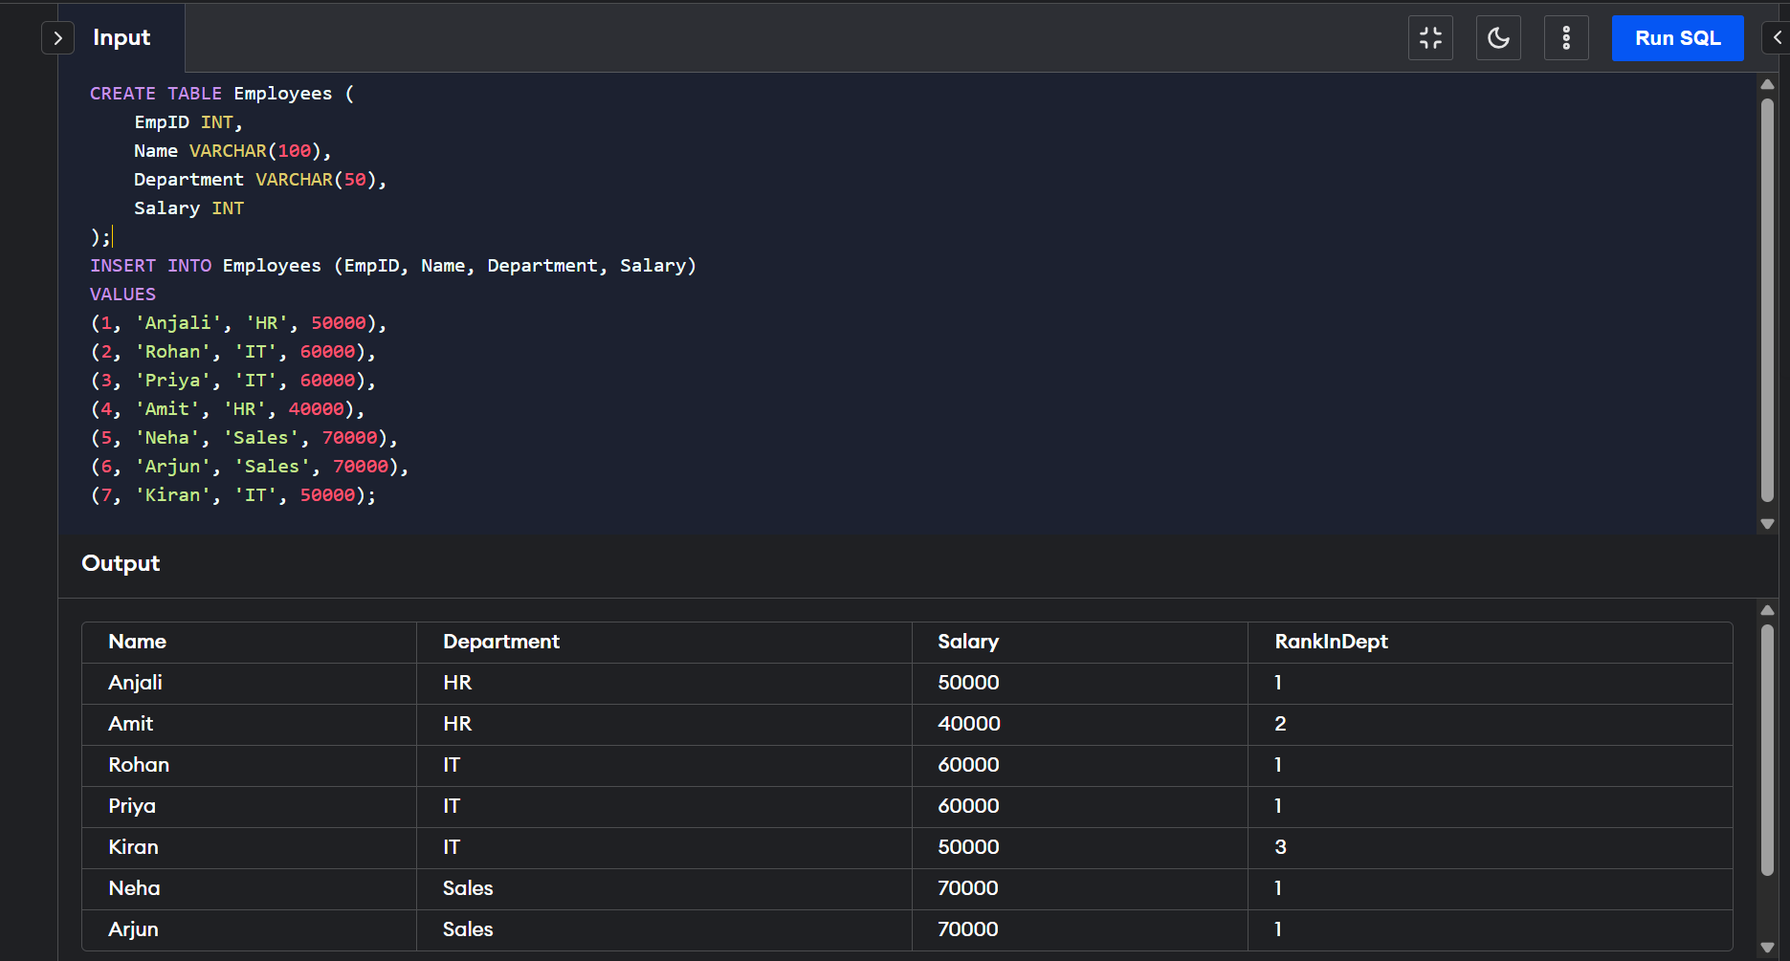

## Query using DENSE_RANK()

SELECT  
 Name,  
 Department,  
 Salary,  
 DENSE_RANK() OVER (PARTITION BY Department ORDER BY Salary DESC) AS DenseRankInDept  
FROM Employees;

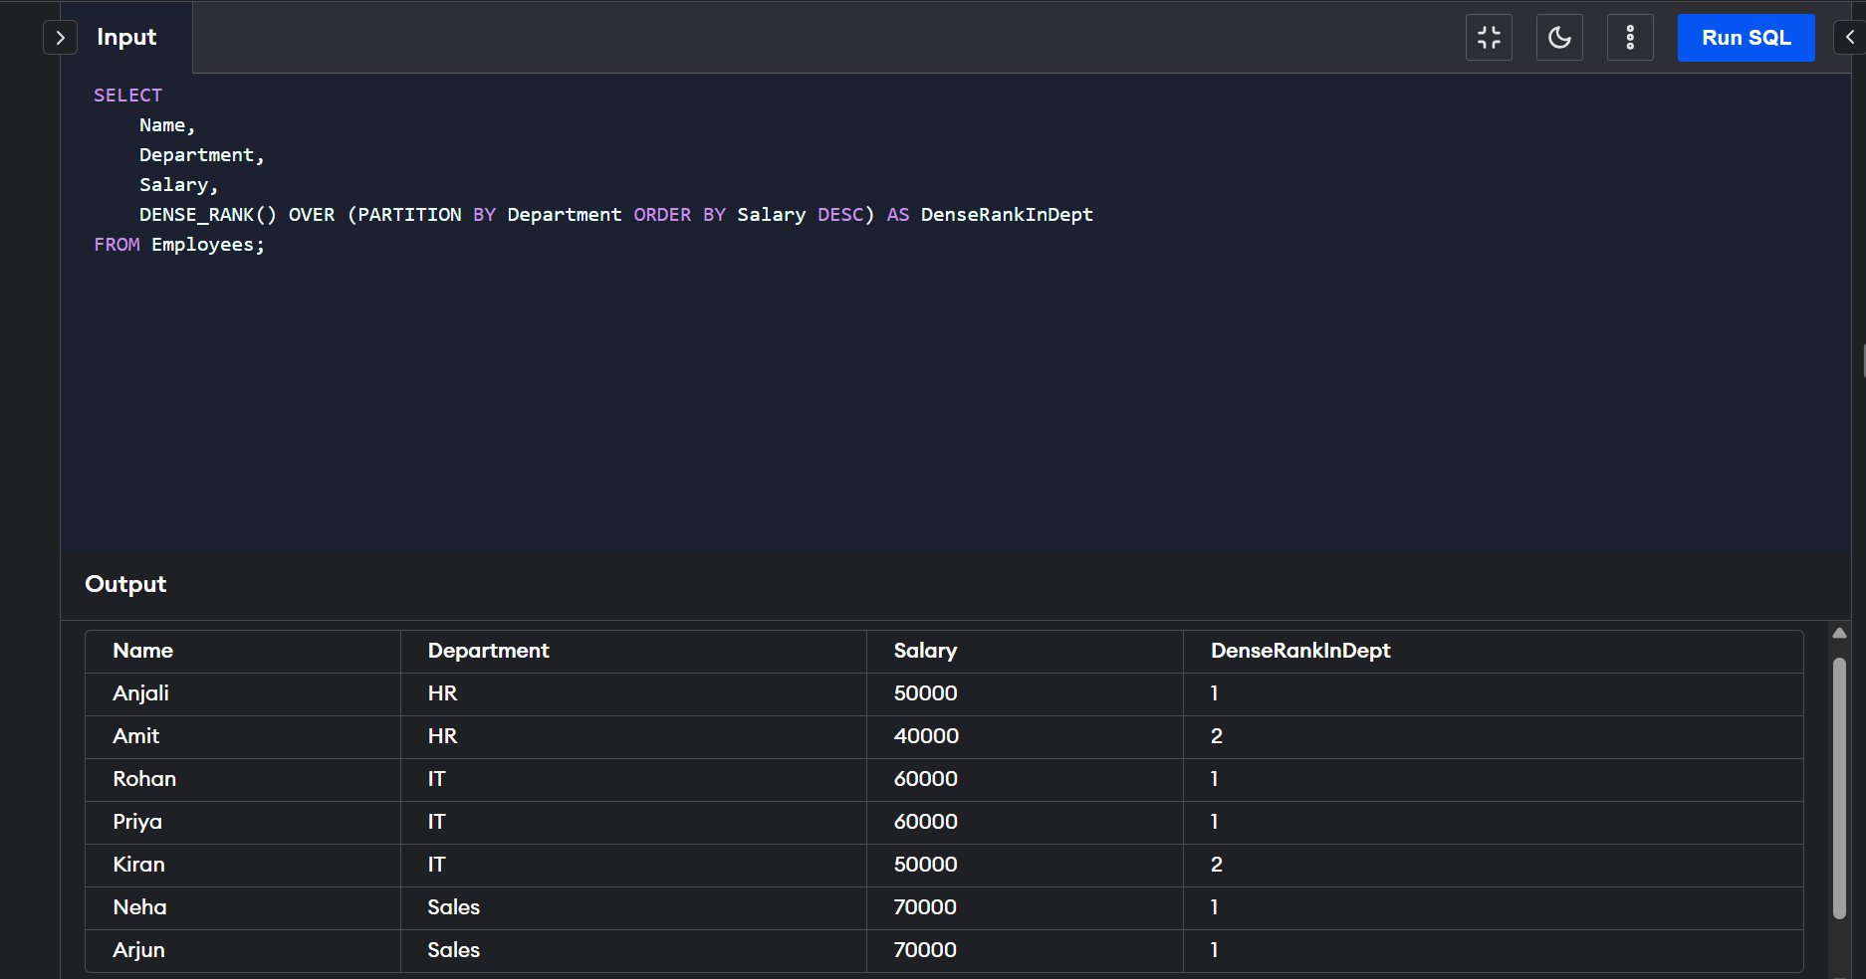

## Query using ROW_NUMBER()

SELECT  
 Name,  
 Department,  
 Salary,  
 ROW_NUMBER() OVER (PARTITION BY Department ORDER BY Salary DESC) AS RowNumInDept  
FROM Employees;

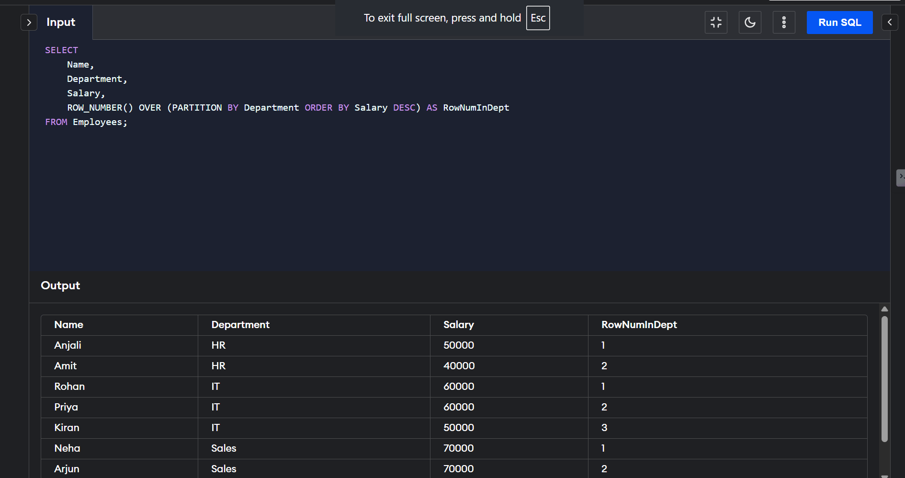

# Exercise 2: Create a Stored Procedure

## Procedure to Insert New Employee

DELIMITER //  
CREATE PROCEDURE InsertEmployee (  
 IN emp_id INT,  
 IN emp_name VARCHAR(100),  
 IN dept VARCHAR(50),  
 IN sal INT  
)  
BEGIN  
 INSERT INTO Employees (EmpID, Name, Department, Salary)  
 VALUES (emp_id, emp_name, dept, sal);  
END //  
DELIMITER ;  
  
CALL InsertEmployee(6, 'Kiran', 'IT', 55000);  
SELECT * FROM Employees;

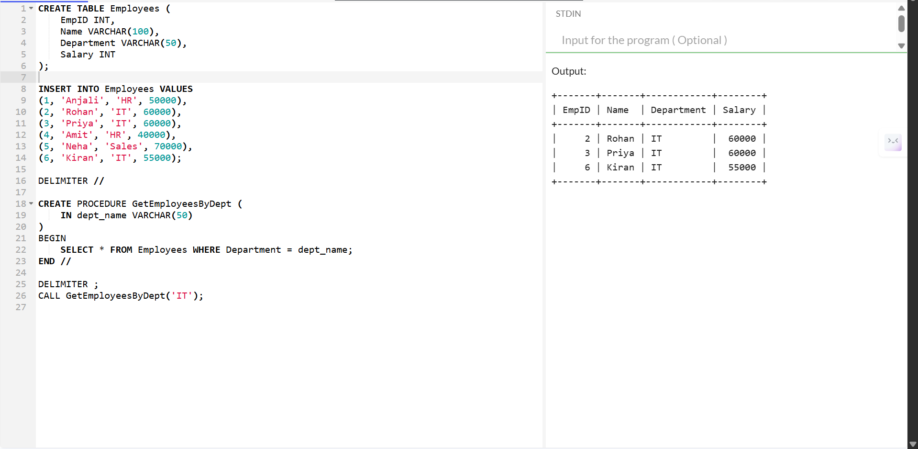

# Exercise 3: Return Data from a Stored Procedure

## Procedure to Retrieve Employees by Department

DELIMITER //  
CREATE PROCEDURE GetEmployeesByDept (  
 IN dept_name VARCHAR(50)  
)  
BEGIN  
 SELECT * FROM Employees WHERE Department = dept_name;  
END //  
DELIMITER ;  
  
CALL GetEmployeesByDept('IT');

